**Iframe/frame**

1. Displaying a webpage as a part another webpage is known as iframe. Iframe will be created by using tagname iframe.
2. Procedure to handle iframe🡪 To handle iframe we need to switch selenium focus from main page to frame by using
3. **driver.switchTo().frame("String NameorId”)**
4. We can switch to frame by 3 ways- i.e. id or name, index, or Webelemt
5. Once action perform on elements present on iframe, selenium will not navigate to main page by default.
6. To navigate from iframe to main we need use method like parent or default content.
7. Driver.switchTo.parentframe(); → Child frame to immediate parent
8. Driver.switchTo.defaultcontent (); → Child frame to main page

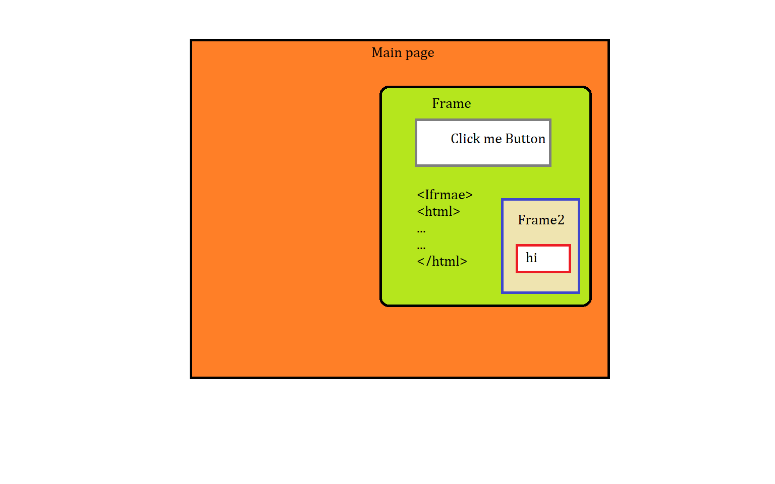

iframe eg1🡪

**package** Iframe;

**import** org.openqa.selenium.By;

**import** org.openqa.selenium.WebDriver;

**import** org.openqa.selenium.chrome.ChromeDriver;

**public** **class** Iframeeg1 {

**public** **static** **void** main(String[] args) **throws** InterruptedException {

System.*setProperty*("webdriver.chrome.driver", "F:\\Velocity\\May-2021 Class\\test2\\chromedriver_win32 (1)\\chromedriver.exe");

WebDriver driver= **new** ChromeDriver();

driver.manage().window().maximize();

driver.get("https://www.w3schools.com/js/tryit.asp?filename=tryjs_myfirst");

Thread.*sleep*(1000);

driver.switchTo().frame("iframeResult");

Thread.*sleep*(1000);

driver.findElement(By.*xpath*("//button[@type='button']")).click();

}

}

Iframe eg3🡪

**package** Iframe;

**import** org.openqa.selenium.By;

**import** org.openqa.selenium.WebDriver;

**import** org.openqa.selenium.chrome.ChromeDriver;

**public** **class** Iframeeg2 {

**public** **static** **void** main(String[] args) **throws** InterruptedException {

System.*setProperty*("webdriver.chrome.driver", "F:\\Velocity\\May-2021 Class\\test2\\chromedriver_win32 (1)\\chromedriver.exe");

WebDriver driver= **new** ChromeDriver();

driver.manage().window().maximize();

driver.get("https://www.w3schools.com/js/tryit.asp?filename=tryjs_myfirst");

Thread.*sleep*(1000);

driver.switchTo().frame("iframeResult");

Thread.*sleep*(1000);

driver.findElement(By.*xpath*("//button[@type='button']")).click();

Thread.*sleep*(1000);

driver.switchTo().defaultContent();// to swich focus to parent frame

Thread.*sleep*(1000);

//driver.switchTo().

driver.findElement(By.*xpath*("(//a[@title='Change Theme'])[1]")).click();

}

}

====================================================================

**package** iFrame;

**import** org.openqa.selenium.By;

**import** org.openqa.selenium.WebDriver;

**import** org.openqa.selenium.chrome.ChromeDriver;

**public** **class** IframeSample1 {

**public** **static** **void** main(String[] args) **throws** InterruptedException {

System.*setProperty*("webdriver.chrome.driver","D:\\Velocity\\Java Class\\5th March B Batch\\chromedriver.exe");

WebDriver driver= **new** ChromeDriver();

//ChromeDriver driver= new ChromeDriver();

driver.get("https://vctcpune.com/selenium/practice.html");

driver.manage().window().maximize();

Thread.*sleep*(1000);

//switch selenium focus from main page to frame

driver.switchTo().frame("iframe-name");

Thread.*sleep*(100);

//current focus is on frame now

driver.findElement(By.*xpath*("(//a[text()='About us'])[1]")).click();// this element is present on iframe(need to switch selenium focus from main page to frame)

// to take action on main page again, we need to switch selenium focus from frame to main page

//parentframe();default content ();

driver.switchTo().defaultContent();// switching selenium focus to main page

driver.findElement(By.*xpath*("//input[@value='Radio1']")).click();

}

}